<http://sizious.com/download/dreamcast/>

Sega Dreamcast Downloads

You’ll find on this page all downloads for your **Sega Dreamcast**video game console. All downloads are compressed in **.7z** format and can be opened with the free [7-zip](http://www.7-zip.org/) archiver. Programs offered on this page can be used directly without any kind of installation, which mean you just need to unzip and run them. Most of them are targeted to [Microsoft Windows](http://en.wikipedia.org/wiki/Microsoft_Windows), because it’s my main computer [OS](http://en.wikipedia.org/wiki/Operating_system).

Summary:

* [AFS2WAV](http://sizious.com/download/dreamcast/#afs2wav)
* [Binary Checker](http://sizious.com/download/dreamcast/#binary-checker)
* [DC-TOOL](http://sizious.com/download/dreamcast/#dc-tool)
  + [DC-LOAD](http://sizious.com/download/dreamcast/#dc-load)
  + [DC-TOOL](http://sizious.com/download/dreamcast/#dc-tool)
* [ELF2BIN](http://sizious.com/download/dreamcast/#elf2bin)
* [IMG4DC](http://sizious.com/download/dreamcast/#img4dc)
  + [BootMake](http://sizious.com/download/dreamcast/#bootmake)
  + [BurnDC CDI For Linux](http://sizious.com/download/dreamcast/#burndc-cdi-for-linux)
  + [Disc-related Various Tools](http://sizious.com/download/dreamcast/#disc-related-various-tools)
* [IP.BIN Creator](http://sizious.com/download/dreamcast/#ipbin-creator)
  + [IPCreate](http://sizious.com/download/dreamcast/#ipcreate)
* [MR-TOOL](http://sizious.com/download/dreamcast/#mr-tool)
* [Selfboot Inducer](http://sizious.com/download/dreamcast/#selfboot-inducer)
  + [SBI Builder](http://sizious.com/download/dreamcast/#sbi-builder)
* [Shenmue Translation Pack](http://sizious.com/download/dreamcast/#shenmue-translation-pack)
* [VMU TOOL PC](http://sizious.com/download/dreamcast/#vmu-tool-pc)

**AFS2WAV**

[AFS2WAV](http://download.sizious.com/dc/afs2wav/afs2wav-1.0.7z) is a Windows program used to extract the contents of AFS files used in most Dreamcast games and to convert the content from [**.ADX**](http://en.wikipedia.org/wiki/ADX_(file_format)) format (proprietary audio codec developed by [CRI Middleware](http://www.cri-mw.com/)) to Waveform files ([**.WAV**](http://en.wikipedia.org/wiki/WAV)). This utility is based on the command-line tool [ADXUtil](http://reocities.com/Area51/nova/3230/" \o "ADXUtil Homepage" \t "_blank), which’s included in the package.

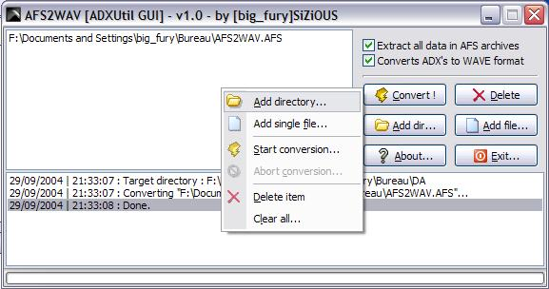

*AFS2WAV*

[Download AFS2WAV](http://download.sizious.com/dc/afs2wav/afs2wav-1.0.7z)

**Binary Checker**

[Binary Checker](http://download.sizious.com/dc/bincheck/bincheck-2.0.7z) (or **BinCheck**) is a tool made to check if your Dreamcast [homebrew binary](http://en.wikipedia.org/wiki/Homebrew_(video_games)" \o "Homebrew Definition" \t "_blank) in **.BIN**format is in **scrambled** or **unscrambled** state.

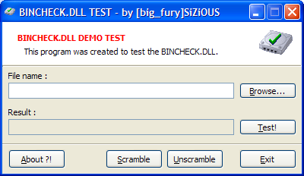

*Binary Checker*

A **.BIN** file is a compiled program for your **Sega Dreamcast**, it’s those that you can get most of time in packages labelled “plain files”. **Scrambled** state files are used when the binary is meant to be booted from a CD-ROM, i.e. when the homebrew program is started from the [bootstrap](http://en.wikipedia.org/wiki/Bootstrapping" \l "Computing" \o "Bootstrap Definition" \t "_blank), often called **IP.BIN**. Such bootable programs are commonly named **1ST\_READ.BIN**. The unscrambled state for binaries, meanwhile, is used in all other cases (e.g. a binary executable started from another binary). Please note **the scrambled/unscrambled state notion is ONLY used for homebrews programs**, i.e. programs compiled with homemade [toolchains](http://en.wikipedia.org/wiki/Toolchain" \o "Toolchain Definition" \t "_blank).

[Download Binary Checker](http://download.sizious.com/dc/bincheck/bincheck-2.0.7z)

**DC-TOOL**

**DC-TOOL** is a set of programs made to send and receive data from your **Sega Dreamcast** system. The classic use of this tool is to send programs to the Dreamcast in order to run and debug them. To be used, you must have a way to connect your Dreamcast console to your computer, it can be one of the following:

* A [Coders Cable](http://x-community.grafbb.com/t872-des-coders-cables-en-vente-en-2013" \t "_blank) (a serial cable, the historical way to do that)
* A [Broadband Adapter](http://segaretro.org/Dreamcast_Broadband_Adapter" \t "_blank), often shortened as “BBA” (a 10/100Mbits network Ethernet card).

This program, originally developed by [ADK/Napalm](http://napalm-x.thegypsy.com/adk/dc/) and now full part of the [KallistiOS](http://gamedev.allusion.net/softprj/kos/" \t "_blank) library (used in the homebrew developments targeted to the **Sega Dreamcast**) is split in two packages:

* **DC-LOAD**, the server part, started from the Dreamcast
* **DC-TOOL**, the client part, started from the computer (can be [GNU/Linux](http://en.wikipedia.org/wiki/Linux) or Windows).

Depending on the method chosen (*Coders Cable* or *BBA*) you must use the right version of the program:

* **DC-LOAD** or **DC-LOAD-SERIAL** for the Coders Cable version
* **DC-LOAD-IP** for the BBA version

This applies on the client part as well, which is called **DC-TOOL**. Initially, **DC-TOOL** is a program usable only within the command line, so I developed a series of GUI for this great tool under Windows.

**DC-LOAD**

Like already said, **DC-LOAD** is the server program meant to be run in the **Sega Dreamcast**. You’ll find below CD images to burn containing the program:

* [DC-LOAD-IP v1.0.3](http://download.sizious.com/dc/dctool/dcload-ip-1.0.3.7z)
* [DC-LOAD-SERIAL V1.0.3](http://download.sizious.com/dc/dctool/dcload-serial-1.0.3.7z)
* [DC-LOAD-IP v1.0.4](http://download.sizious.com/dc/dctool/dcload-ip-1.0.4.7z)
* [DC-LOAD Covers](http://download.sizious.com/dc/dctool/dcload-cover.7z)

For burning these CD images, you can use either [Padus DiscJuggler](https://www.padus.com/" \o "Padus DiscJuggler" \t "_blank) or [Alcohol 120%](http://www.alcohol-soft.com/). Please burn them at the slowest speed as possible.

**DC-TOOL**

When you have downloaded the right version of the server part (**DC-LOAD**), now you need to download the client part to run in your computer (**DC-TOOL**). As **DC-LOAD**, you need to use either **DC-TOOL-SERIAL** or **DC-TOOL-IP**.

* [DC-TOOL 2013-03-02 MinGW](http://download.sizious.com/dc/dctool/dctool-20130302-mingw32.7z): It’s the **Serial** and **IP** binaries in the same package, compiled with the latest source code from the [KallistiOS SVN](http://sourceforge.net/projects/cadcdev/" \o "KallistiOS SVN" \t "_blank). It’s the original programs without any form of GUI.
* [TURBO DC-TOOL GUI](http://download.sizious.com/dc/dctool/dctcontx-1.0.7z): This program is a simple GUI for **DC-TOOL** (**Serial** or **IP**), with a high shell integration for the Windows Explorer.



*TURBO DC-TOOL GUI*

* [DC-TOOL GUI 2.0](http://download.sizious.com/dc/dctool/dctoolgui-2.0.7z): It’s a GUI for **DC-TOOL**, very easy and nice to use.

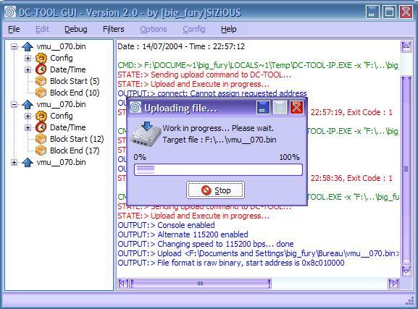

*DC-TOOL GUI 2.0*

* [DC-TOOL GUI 3.0 beta 1](http://download.sizious.com/dc/dctool/dctoolgui-3.0b1.7z): It’s the bêta 1 of the 3.0, which has never been finished.

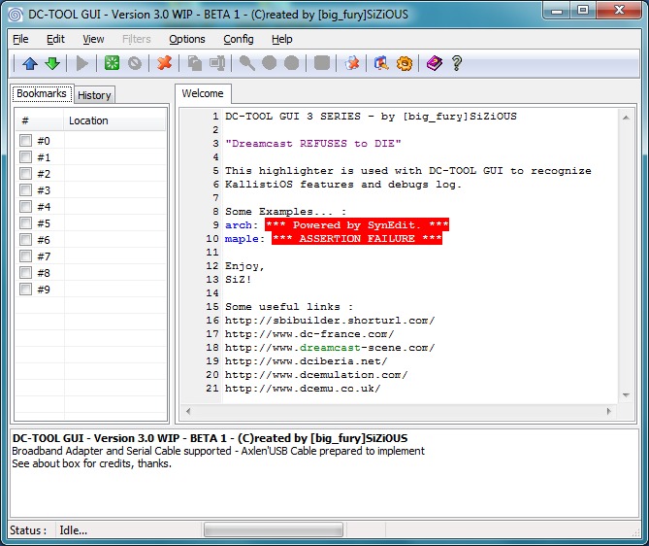

*DC-TOOL GUI 3.0 Beta 1*

**ELF2BIN**

This program is mainly dedicated to programmers who want to convert [**.ELF**](http://en.wikipedia.org/wiki/Executable_and_Linkable_Format) programs to the **.BIN**format, necessary to allow the **Dreamcast** program to be bootable from a CD-ROM via the scrambled state. This’s a standalone version of the “sh-elf-objcopy” utility. This program works with or without GUI.

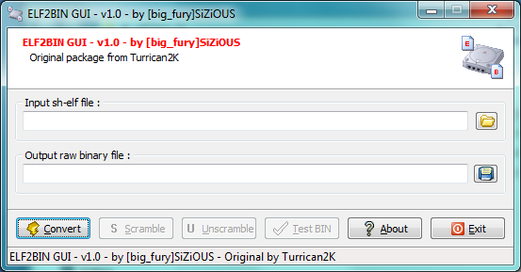

*ELF2BIN*

[Download ELF2BIN](http://download.sizious.com/dc/elf2bin/elf2bin-1.0.7z)

**IMG4DC**

This package allows you to generate bootable CD images for your **Sega Dreamcast**. It’s split in two separate programs, usable in command-line mode:

* **CDI4DC** : for generating Padus DiscJuggler CD images
* **MDS4DC** : for generating Alcohol 120% CD images.

These programs have become since 2007 a ​​reference in the **Sega Dreamcast** homebrew world, and they are used in other third-party tools such [BootDreams](https://code.google.com/p/bootdreams/" \o "BootDreams" \t "_blank). For these reasons [I gave the source code to the community](http://sourceforge.net/projects/img4dc/).

[Download IMG4DC 2012-05-12](http://download.sizious.com/dc/img4dc/img4dc-20120512.7z)

**BootMake**

[BootMake](http://download.sizious.com/dc/img4dc/bootmake-1.2-cdi4dc-0.3b.7z) is a very simple GUI program for **CDI4DC** only.

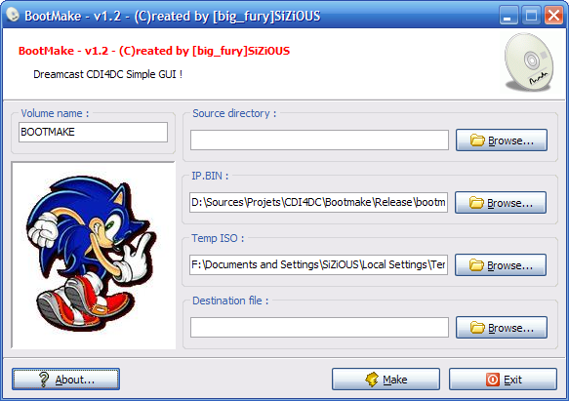

*BootMake*

[Download BootMake](http://download.sizious.com/dc/img4dc/bootmake-1.2-cdi4dc-0.3b.7z)

**BurnDC CDI For Linux**

It’s a shell script for Linux designed to burn CDI files. Indeed CDI files are **Padus DiscJuggler** images which is a Windows-program only. This script makes possible to burn CDI under [GNU/Linux](http://en.wikipedia.org/wiki/GNU/Linux) systems.

[Download BurnDC CDI For Linux](http://download.sizious.com/dc/img4dc/burndc-cdi-linux.zip)

**Disc-related Various Tools**

These tools weren’t made by me, but it may be useful to you:

* [CDIrip](http://download.sizious.com/dc/img4dc/cdirip-0.6.3.7z): Extracts CDI images into several track files.
* [CDI2Nero](http://download.sizious.com/dc/img4dc/cdi2nero-0.9.9.7z): Converts CDI images into [Nero Burning ROM](http://www.nero.com/) images. A [modified version](http://download.sizious.com/dc/img4dc/cdi2nero-0.9.9-mod.7z" \o "CDI2Nero) by me is also available, changes are listed in the archive.
* [gditools](http://sourceforge.net/projects/dcisotools/): This Python program/library made by FamilyGuy is designed to handle GD-ROM image (GDI) files. I’ve just made the multiplatform GUI.

**IP.BIN Creator**

This tool was made to generate “[bootstrap](http://fr.wikipedia.org/wiki/Amor%C3%A7age_d%27un_ordinateur" \o "Programme d'amorçage" \t "_blank)” **IP.BIN** (*Initial Program*) files for your **Sega Dreamcast** console. This tool is mainly for developers but can be used for the end-user to generate customized bootstraps (e.g. with custom logos). The bootstrap is the license screen shown at startup when you run any Dreamcast program (e.g. [Shenmue](http://shenmuesubs.sf.net/" \o "Shenmue Translation Pack" \t "_blank) or whatever).



*IP.BIN Creator*

[Download IP.BIN Creator](http://download.sizious.com/dc/ipbuild/ipbuild-1.0.7z)

**IPCreate**

This program is the console version of the tool above, originally made for **LyingWake** and his [BootDreams](https://code.google.com/p/bootdreams/" \o "BootDreams" \t "_blank) tool.

[Download IPCreate](http://download.sizious.com/dc/ipbuild/ipcreate-1.1.7z)

**MR-TOOL**

This utility was initially written by **\_kRYPT**and was made for convert various pictures format (such as **.JPG**, **.PNG** or **.BMP**) in the special **.MR** format, used with the boostrap file (“**IP.BIN**“). Please note that algorithm used in this tool is now deprecated, a new version of this library was written for **Selfboot Inducer** that you can just download below.

[Download MR-TOOL](http://download.sizious.com/dc/mrtool/mrtool-0.6.7z)

**Selfboot Inducer**

This tool was made for creating homebrews compilations on the same CD-ROM for your **Sega Dreamcast**. In clear, you may put several proggies in the same CD-ROM and **Selfboot Inducer** will create you a CD-ROM embedding a menu for selecting what program you want to run when putting this disc in your **Sega Dreamcast** console. It was very popular before the **SD Card** module release. To use this tool you need to download homebrews programs in the special **.SBI** format (see below). It’s the latest program I wrote for my favorite video console system. The complete source code is included in the package, written in [Delphi XE2](http://www.embarcadero.com/fr/products/delphi). You’ll find in that source code a new implementation of the encoding/decoding algorithm for **.MR** files (used in bootstraps).

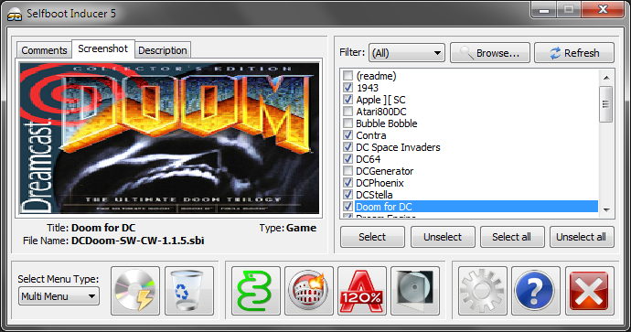

*Selfboot Inducer*

[Download Selfboot Inducer](http://download.sizious.com/dc/sbi/sbinducr-5.0.7z)

**SBI Builder**

This utility is the ideal companion for **Selfboot Inducer** because it can create the famous **.SBI** packages necessary to build your own compilations. The user-interface of the tool is available in english, french and spanish. It was historically the first program I wrote for the **Dreamcast**, that’s why I used its name for my differents websites until today. A dozen of versions was released.



*SBI Builder*

[Download SBI Builder](http://download.sizious.com/dc/sbi/buildsbi-3.2.7z)

**Shenmue Translation Pack**

The **Shenmue Translation Pack** is a big package containing tools used to modify the in-game subtitles and every game data in order to localize in your own language **Shenmue**, **What’s Shenmue** and **Shenmue II**, on both **Sega Dreamcast** and **Microsoft Xbox**. I’m working on that project since 2008.



*Shenmue Translation Pack*

[Download Shenmue Translation Pack](http://shenmuesubs.sourceforge.net/)

**VMU TOOL PC**

This nice utility was made in collaboration with another french developer, [speud](http://bswirl.kitsunet.org/" \o "Blue Swirl" \t "_blank), author of the nice [DreamExplorer](http://bswirl.kitsunet.org/vmutool/release/downloads/?lg=en&menu=on" \o "DreamExplorer" \t "_blank) tool, formerly known as **VMU TOOL**. It’s a **Sega Dreamcast**saves files manager for your computer. It can handle**.VMS**/**.VMI** and **.DCI** files.

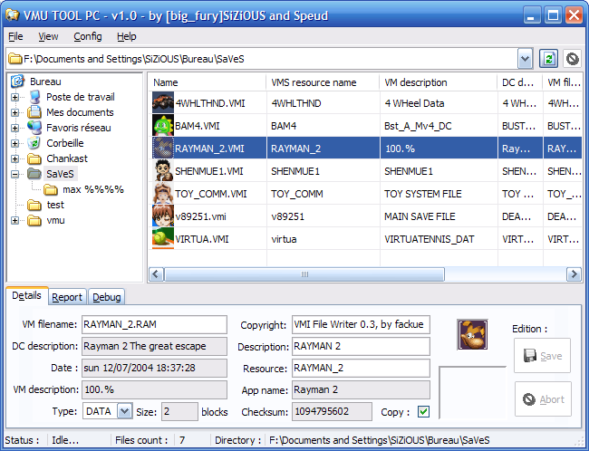

*VMU TOOL PC*

[Download VMU TOOL PC](http://download.sizious.com/dc/vmutool/vmutoolpc-1.0.7z)